A
Mini Project Report
on
<Name of project Topic>
Submitted in partial fulfillment of the requirements for the
degree
Second Year Engineering – Computer Science Engineering (Data Science)
by
<group member 1> Moodle ID
<group member 2> Moodle ID
<group member 3> Moodle ID

Under the guidance of

<Guide name>

DEPARTMENT OF COMPUTER SCIENCE ENGINEERING (DATA SCIENCE)
A.P. SHAH INSTITUTE OF TECHNOLOGY
G.B. Road, Kasarvadavali, Thane (W)-400615
UNIVERSITY OF MUMBAI

Academic year: 2025-26

CERTIFICATE

This to certify that the Mini Project report on <project title> has been submitted by _________________________(Student ID), ________________________ (Student ID) ), ________________________ (Student ID) and _________________________(Student ID) who are bonafide students of A. P. Shah Institute of Technology, Thane as a partial fulfillment of the requirement for the degree in Computer Science Engineering (Data Science), during the academic year 2025-2026 in the satisfactory manner as per the curriculum laid down by University of Mumbai.

<Guide Name>
Guide

Dr. Pravin Adivarekar Dr. Uttam D. Kolekar
HOD, CSE(Data Science) Principal

External Examiner: Internal Examiner:
- 1.

Place: A. P. Shah Institute of Technology, Thane
Date:

ACKNOWLEDGEMENT

This project would not have come to fruition without the invaluable help of our guide <Guide Name>. Expressing gratitude towards our HoD, Dr. Pravin Adivarekar, and the Department of Computer Science Engineering (Data Science) for providing us with the opportunity as well as the support required to pursue this project. We would also like to thank our project coordinator Prof. Richa Singh and Prof Kiran Gaikwad who gave us her valuable suggestions and ideas when we were in need of them. We would also like to thank our peers for their helpful suggestions.

TABLE OF CONTENTS

- Introduction………………………………………………………………………..1
  - Purpose.............................................................................................................1
  - Problem Statement…………………………………………………………...2
  - Objectives........................................................................................................ 2
  - Scope.........................................................................................................…...3
- Proposed System………………………………………………………………......4
  - Features and Functionality…………………………………………………...4
- Project Outcomes.............................................................................................…....6
- Software Requirements............................................................................................7
- Project Design……………...…………………………………………...................8
- Project Scheduling..................................................................................................10
- Results…………………………………………………………………………….11
- Conclusion…………………..................................................................................17
References

Chapter 1 <Times New Roman with font size 18 and bold>
Introduction <Times New Roman with font size 16 and bold>
The title of Chapter 1 shall be Introduction. It shall justify and highlight the problem posed, define the topic and explain the aim and scope of the work presented in the report. It may also highlight the significant contributions from the investigation.
<main Content of report must be in Times New Roman with font size 12 & with justified alignment, space between the line must be 1.5 throughout report>
  - Purpose: <Times New Roman with font size 14 and bold>
Specify the purpose of the document including its target audience.
  - Objectives:
Note: Add all chapters as per index one after another.
- Format to Represent Diagrams in report :
Each diagram must be horizontally aligned at center and the content of each diagram must be in readable form. Diagram name must be below the diagram in times new roman with font size 11 and bold.
e.g. Figure 3.1: Waterfall model
- Format to Represent Table in report :
After every table mention table name in times new roman with font size 11 and bold.
e.g. Table 1.1: Comparison of Algorithms

<Main Instruction : All the content of report must be with justified alignment and with spacing of 1.5 throughout the report. Also maintain the proper indentation while preparing report>
ALL THE PAGES AFTER INDEX MUST BE WITHOUT BORDER
Project Scheduling Template
Please prepare Gantt Chart for the project scheduling as per your project tasks and work completed.
<Like wise students are expected to prepare schedule for project implementation related activities which they are expected to complete in this semester. The schedule should be prepare from July to October month>
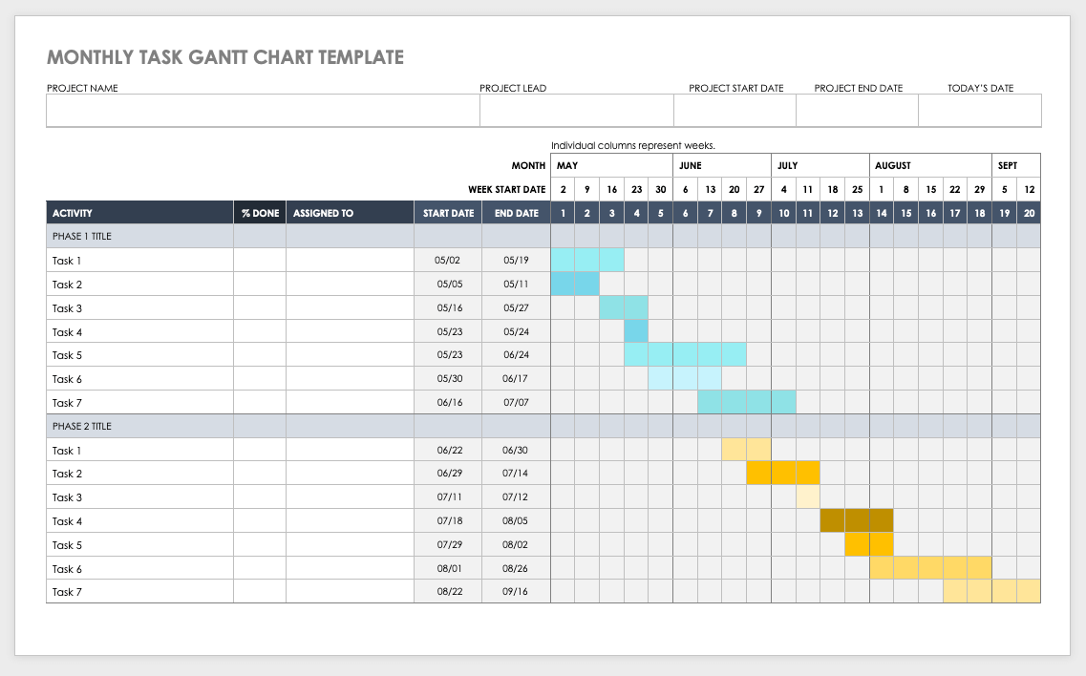
References
[1] Abror Abduvaliyev, Al-Sakib Khan Pathan, Jianying Zhou, Rodrigo Roman and WaiChoong Wong ,“On the vital Areas of Intrusion Detection Systems in Wireless Sensor networks”,IEEE Communications Surveys & Tutorials, Accepted For Publications, 2013-in press.
[2] H.H. Soliman, et al,“A comparative performance evaluation of intrusion detection techniques for hierarchical wireless sensor networks”, Egyptian Informatics Journal (2012) 13, 225238.
[3] Giannetsos Athanasios, “Intrusion Detection in Wireless Sensor Networks”, Master THESIS, Carnegie Mellon University, April 8, 2008.
[4] K.Fall and K.Varadhan,“The NS Manual”, http://www.isi.edu/nsnam/ns/doc/ns doc.pdf., 1 Feb 2014.
[5] Jae Chung and Mark Claypool,“NS by Example-Tutorial”, http://nile.wpi.edu/NS/overview.html , 1 Feb 2014.
[6] Network Simulator blog, http://Mohittahilani.blogspot.com , 1 Feb 2014.
[7] AWK Script for NS2, http://mohit.ueuo.com/AWK-Scripts.html , 1 Feb 2014.

